**ITSS 4351 Foundations of Business Intelligence**

**Assignment 5 – 150 points**

**Mining Models/Tableau/SSRS/Crystal Reports**

Note:

* 1. Use the AdventureWorks2014 Database and the vTargetMail view.
  2. Partial Screenshots will not be evaluated. Your screenshots should cover the entire screen and prominently show your work
  3. **ONLY ONE SUBMISSION** is allowed. Please ensure that you submit the exam carefully.
  4. No Late Submission is allowed. The key will be made available right after the submission deadline and hence no late submissions will be allowed.

**Your Name: Tiffany Lourdraj**

# SQL Server – 65 points

**You are required to create a Decision Tree and Clustering Model**

1. You are required to predict the BikeBuyer quotient using any input which has a Score of at least 0.015. **Paste a Screenshot of all the selected inputs - 5 points**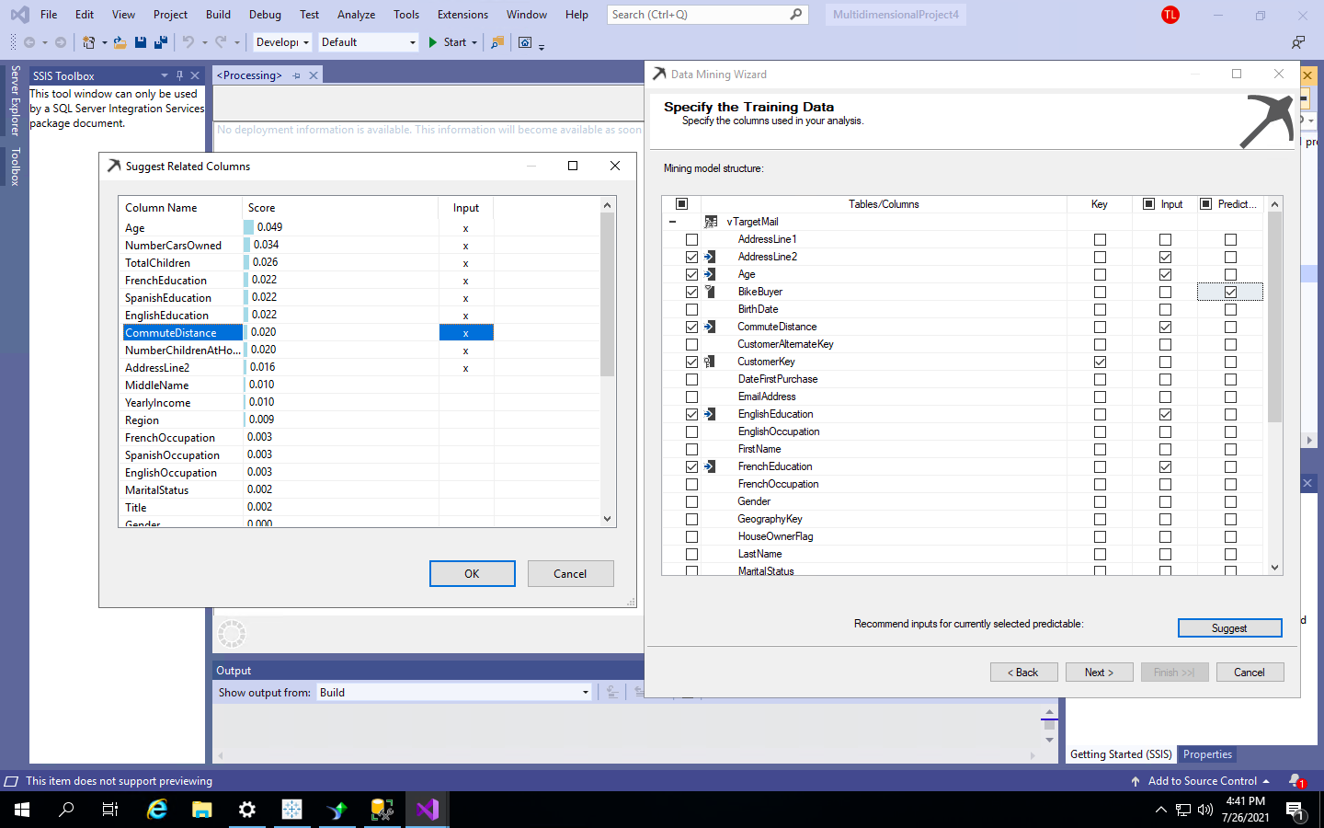
2. Ensure the Content Type is aligned with what Visual Studio recommends. Using 30% data for testing and Allowing Drill Through, create a Decision Tree. Compare it with the Clustering Model and find out which one has a better score, for BikeBuyer = 1. What are the scores? **Paste a screenshot of the mining legend. – 5 points**

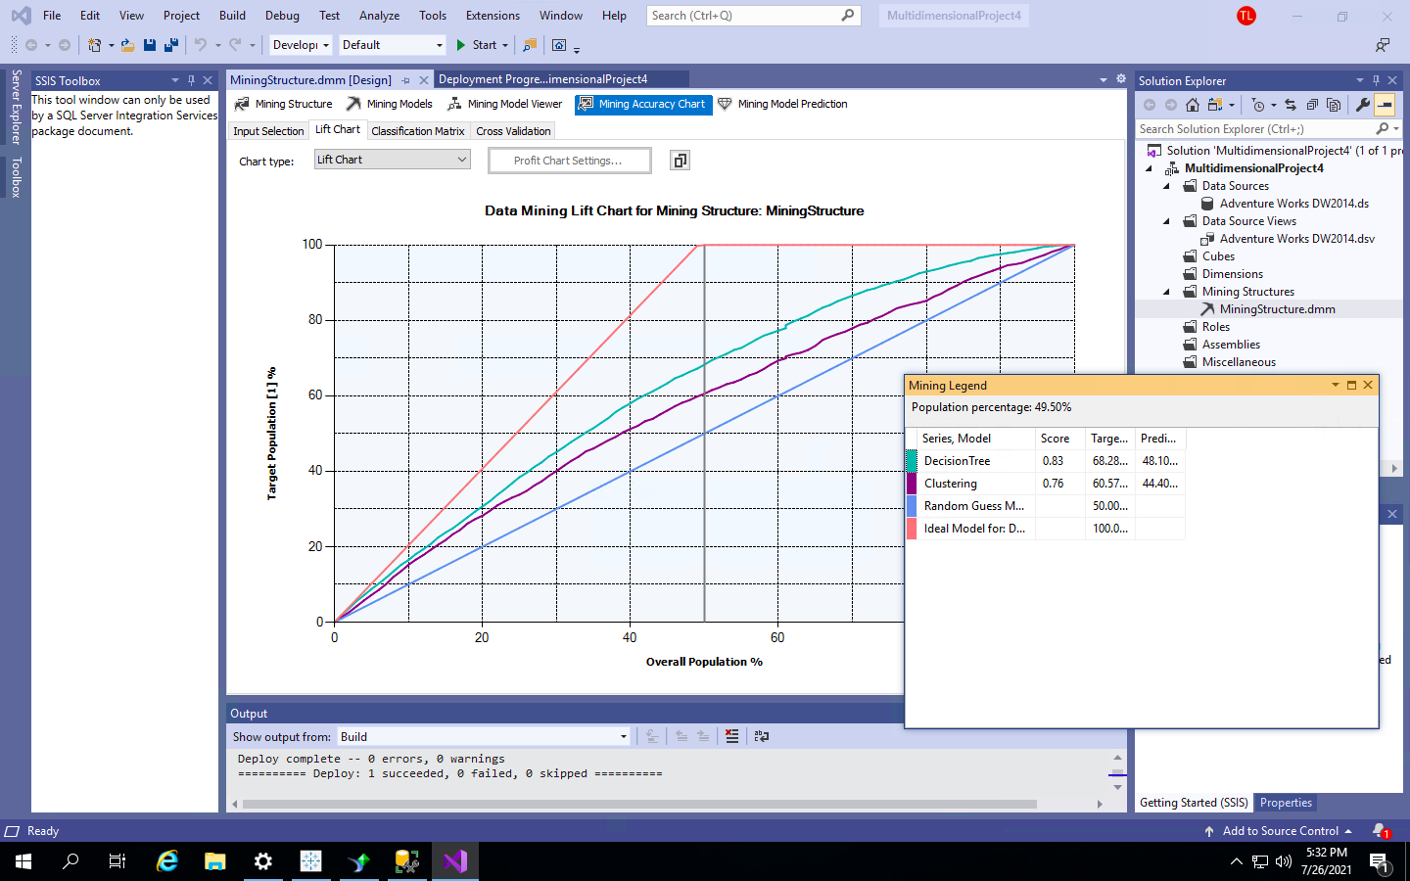

**Decisión tree has 83%**

**Clustering has 76%**

**that means the decisión tree is better at prediction since it has a higher score.**

1. In a Decision Tree, other than the Dependency Network, how can we find out which input is the strongest in terms of helping predict the output. List/Describe how would you find out the strongest input without using the Dependency Network – **5 points**
   1. **look to the darkest color of the rectangles connected to the darkest color rectangle in the decisión tree under mining model viewer**
   2. **hover over the rectangles and it shows which one has the highest number**
   3. **you can find the highest number possible by looking at the default expansion and going to 3,4,5 levels shows the highest numbers through out the tree with the total cases**
2. If I live in a Town with the population of 65,000, using the Clustering, if my Fixed Cost is $12000, and I want to earn $20 per individual, what is the maximum (upto 1 decimal place) I can spend on an individual so that I don’t make a loss. **Paste the screenshot of the ‘Profit Chart Settings’ and the Mining Legend. Describe the numbers you get for the decision tree as opposed to Clustering – 20 points**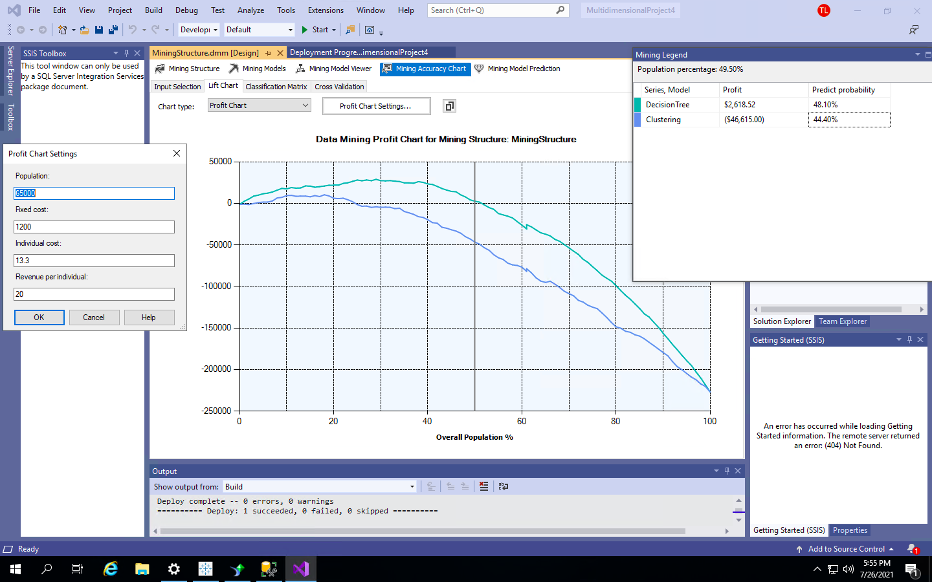

The decision tree cannot mining legend cannot go into the negatives if you want to make a profit I cannot go below $13.3 for a person if I want to earn $20 from a person. if I go more than this number I make a loss. my smallest margin is going to be $2,618.52 of profit.

1. The Cluster which has the maximum percentage of people who bought a bike. Describe this cluster using 3 inputs. **Paste a screenshot of this cluster and** **Write your description – 10**

**points**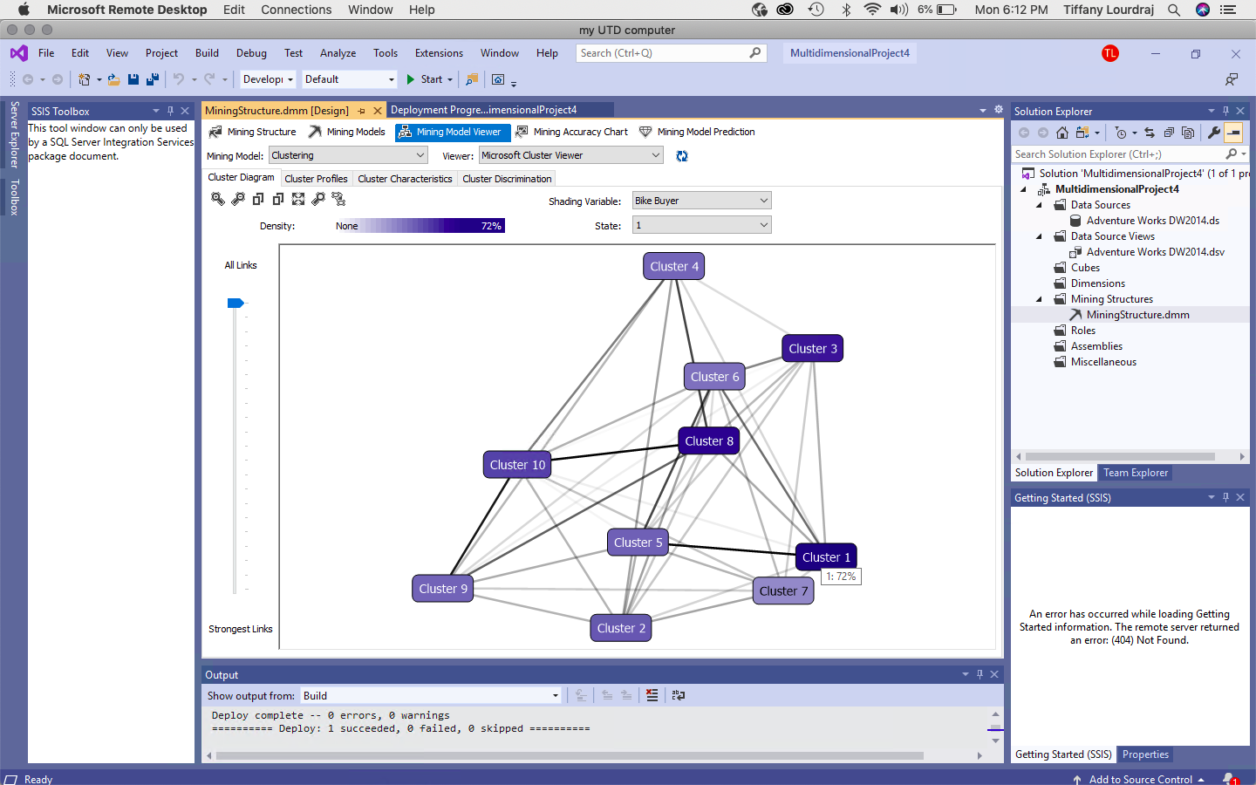

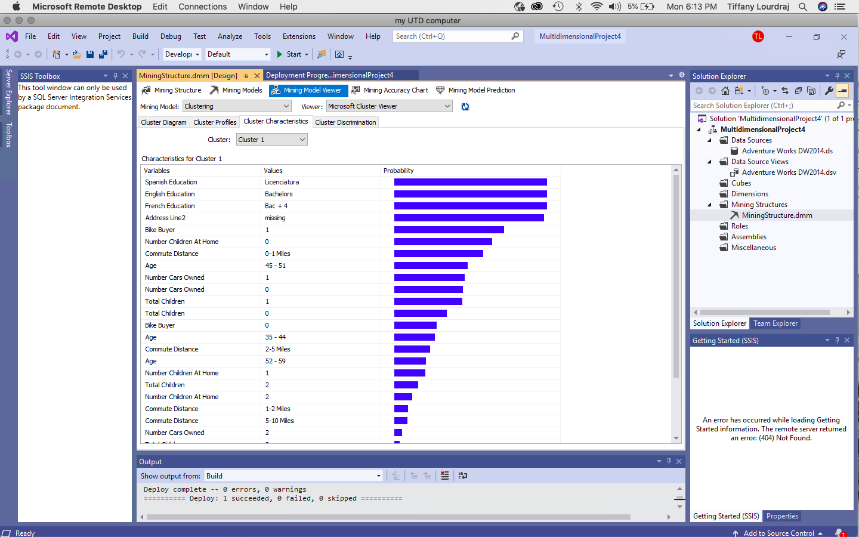

Cluster 1 has the the greatest density which is the highest amount which is equivalent to 72%. you

will find the highest density when you find the darkest colored circle. This is why I chose cluster

1 for the maximum percentage of people who bought a bike. Spanish education, french education

and english education and Address Line 2 all have a major impact on the biker buyers

decisión.

1. Compare Cluster 1 to the rest. **Paste a screenshot of this comparison and describe your findings – 10 points**

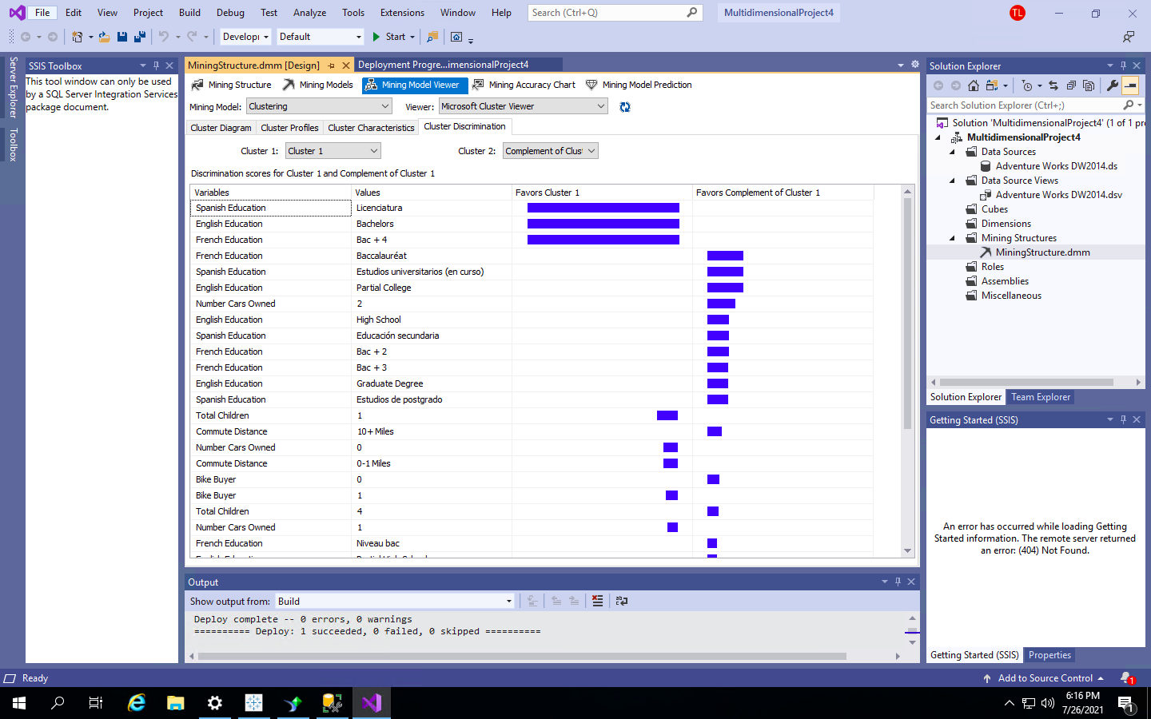

In this cluster comparison, the spanish (licenciatura), french(bac+4) and english (bachelors) education all favor cluster 1 by 100%. However for French education (baccalaureate) spanish (estudios), english (partial) , high school , bac +3,2, and graduate degree all favor the complement of cluster 1.

1. Using Mining Model Prediction, find out the likelihood of someone buying a bike (Hint: Use the Predict Function to Predict Probability), using the Decision Tree and the ProspectiveBuyerTable. Include the following attributes
   1. Prospective Buyer Key
   2. First Name
   3. Last Name
   4. Email Address
   5. House Owner Flag
   6. StateProvinceCode
   7. City
   8. Occupation
   9. Yearly Income
   10. Number of Cars Owned
   11. Number of Children at Home

**Paste the screenshot of the results, whatever can be captured in one go. – 10 points**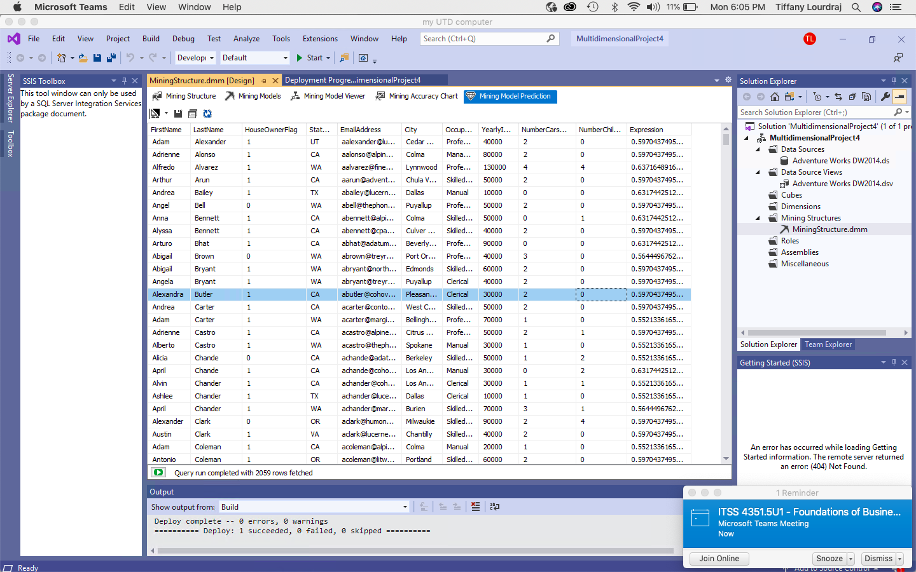

# Tableau – 35 points

1. Import the Results from Ques#7 into Tableau (Hint: Copy the results onto an excel sheet) and create a Dashboard with the following Sheets -
   1. Use a Butterfly Chart to depict the Average Number of Cars Owned and Average Number of Children at Home for each state. **Paste a Screenshot of the sheet. – 15 points**

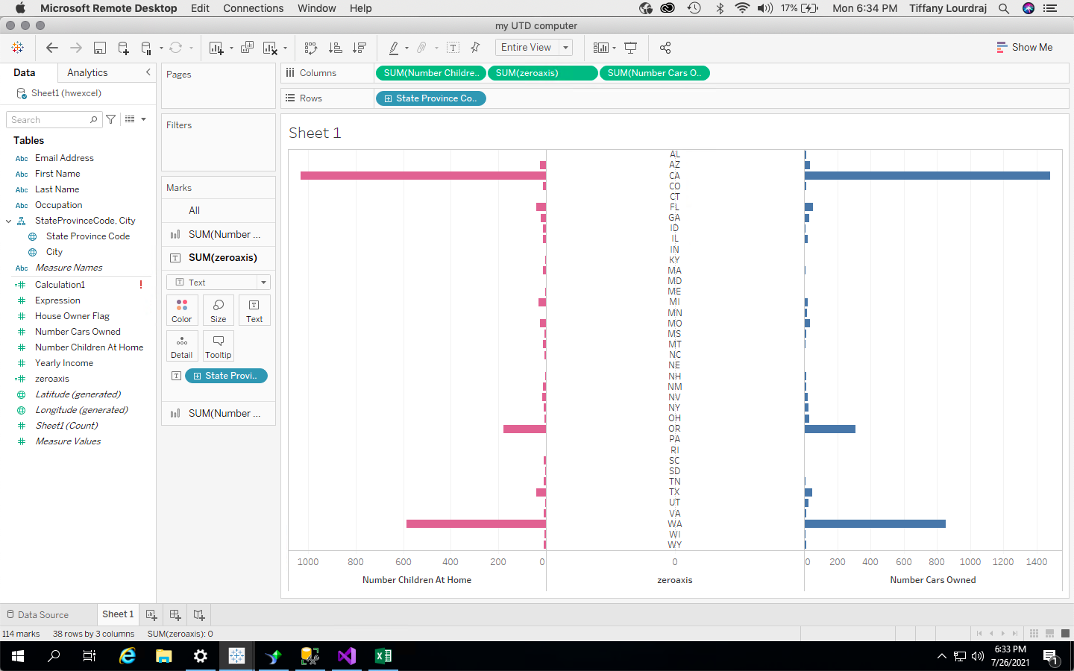

* 1. Using any chart to bring together the Occupation, Average Yearly Income and the ‘Probability of Buying a Bike’ **Explain your chart and paste a screenshot of the sheet – 15 points**

I used a bar chart to compare the numbers of the impact of occupation on income and bike buying. This is showing a clear correlation between lower income and the amount of the probability of bike buying. I thought a bar chart could most clearly illustrate how these two variables are interconnected.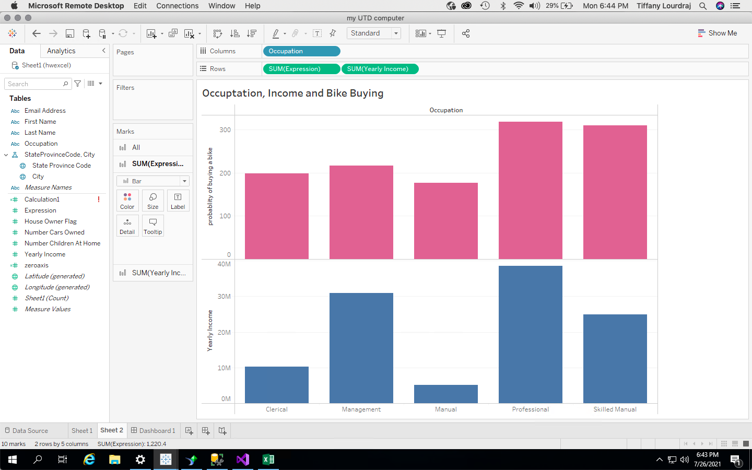

* 1. Create a Dashboard with the above two sheets and Add a Floating Title – “Final Exam”. **Paste a Screenshot – 5 points**

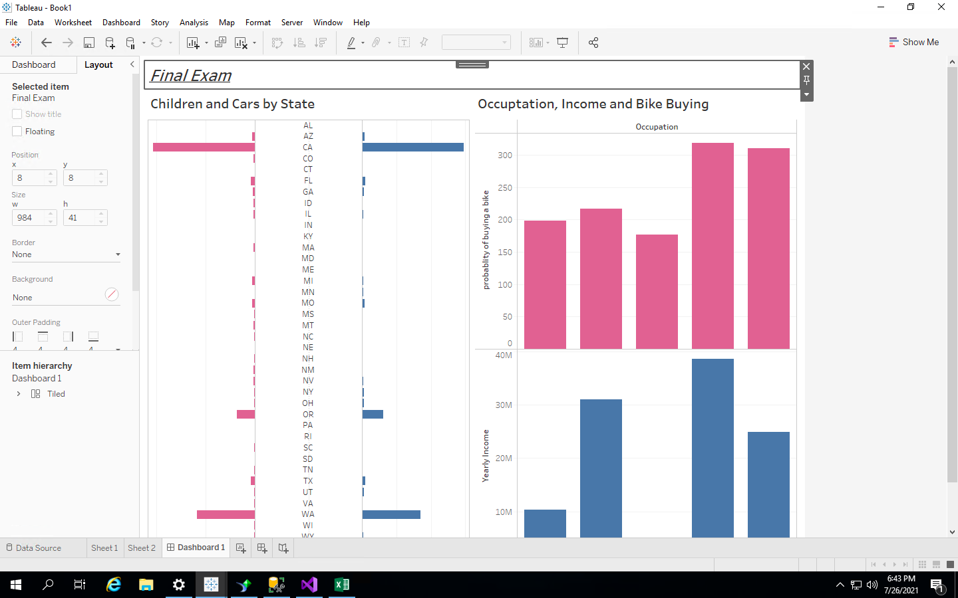

# SAP Crystal Reports – 30 points

1. Create a new connection to the AdventureWorksDW database. Select the table – ProspectiveBuyer. List all the fields in the “Fields Explorer”. Paste a Screenshot – 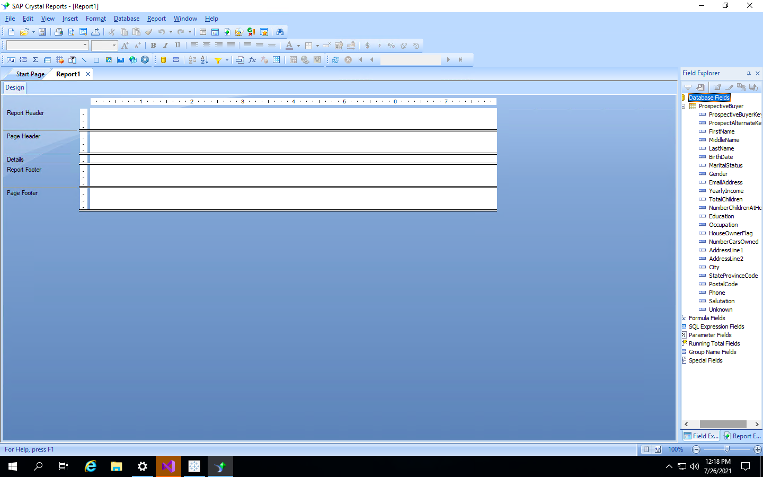
2. Create a Report with the following
   1. First Name
   2. Last Name
   3. Gender
   4. Email Address
   5. Report Header – “End Semester Assignment”. Align it – Center and Bold it
   6. Add the Page Number at the Bottom
   7. Paste a Screenshot of the Design View – 10 points

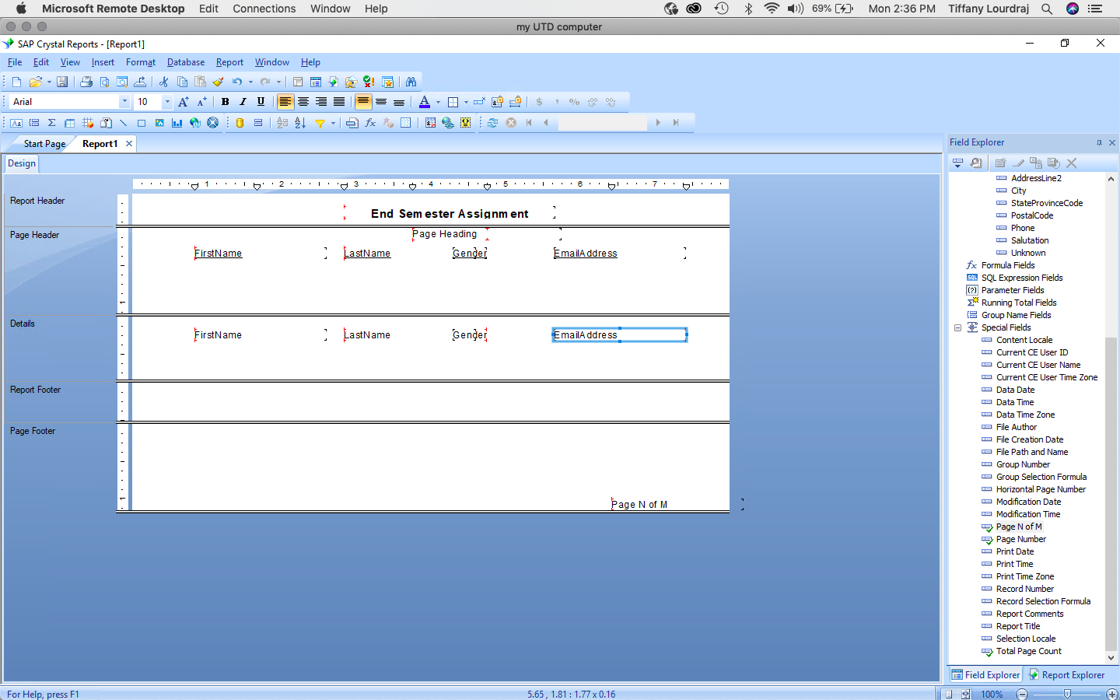

1. Add a new Parameter for Marital Status. Let the Parameter show multiple values. Add a Prompt to filter your report. Paste a Screenshot of the Prompt Window – 10 points

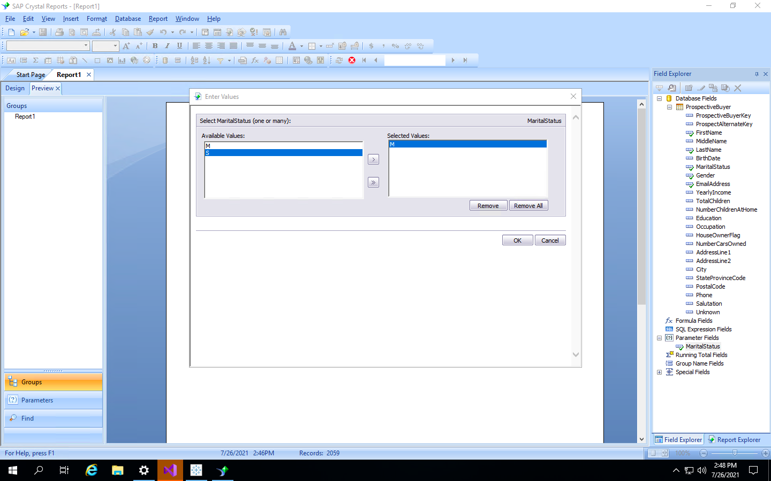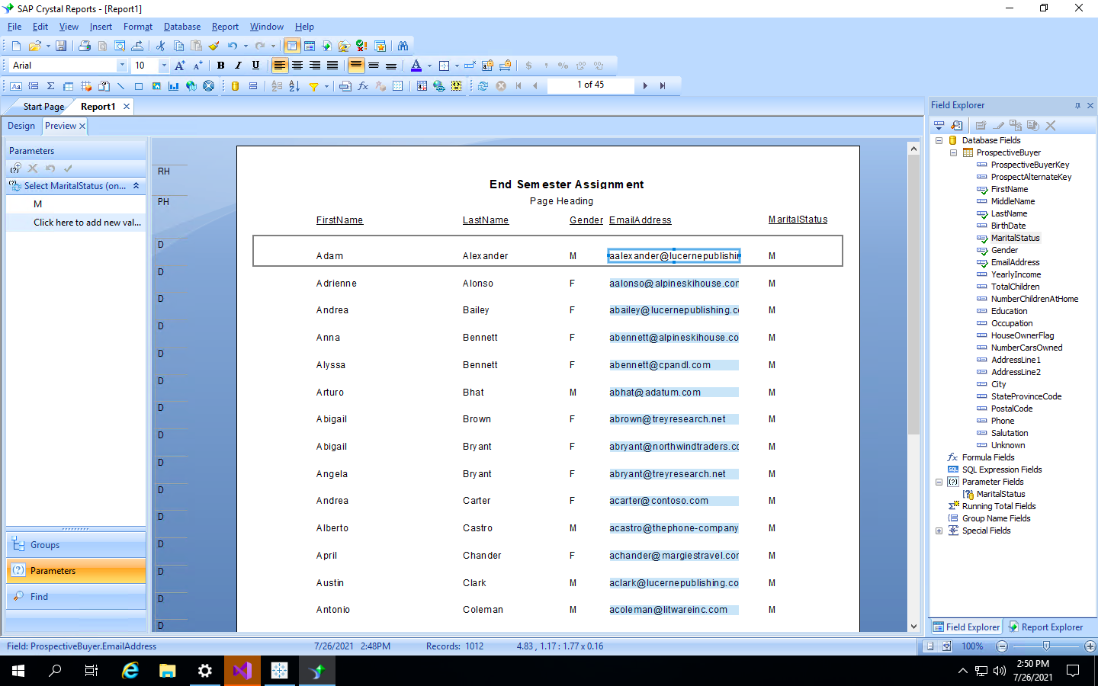

# SSRS – 20 points

1. Using ProspectiveBuyer, create a report in SSRS
   1. First Name
   2. Last Name
   3. Gender
   4. Email Address
   5. Report Header – “End Semester Assignment”. Align it – Center and Bold it
   6. **Paste a Screenshot of the Results – 15 points**

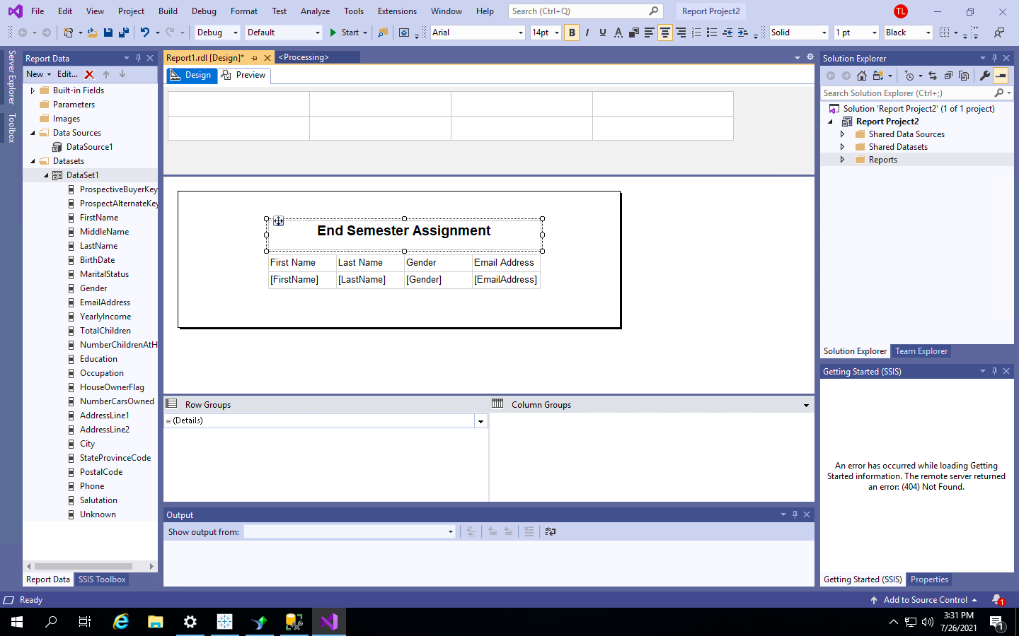

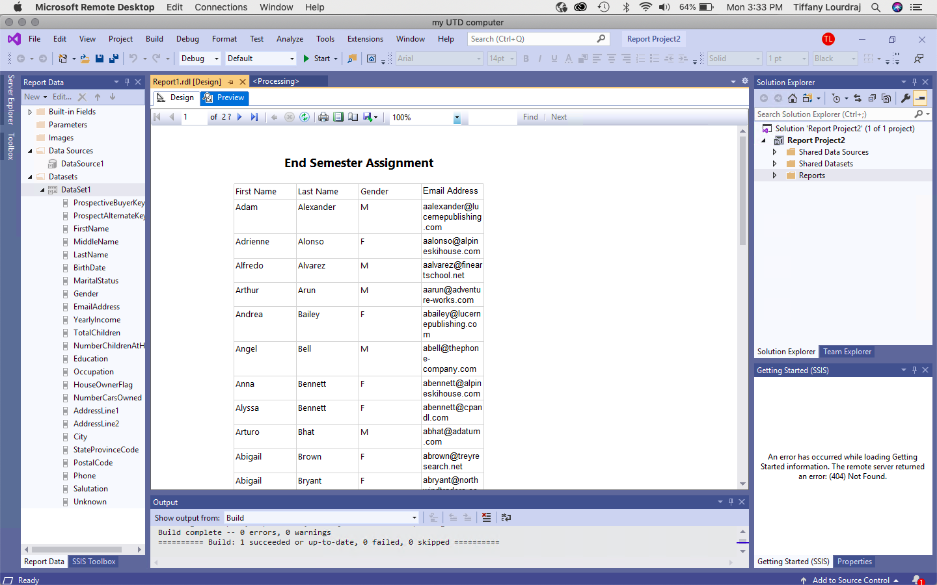

1. When you use a Shared Data Source in a report(screenshot below for reference), you are not able to change the credentials. Is this a bug or not a bug? Why do you think Visual Studio behaves this way? **– 5 points**

if I need to use any kind of credentials, and because it is a shared data source, the credentials need to be set on the shared end. Five different reports could be using the same data source, so this is not a bug, but a safety protocol to prevent loss or editing of data. Therefore, you cannot change the credentials.

